System and Software Architecture Description (SSAD)

United Directed Marketing

Team 9

Fall Semester
Chun-Ling Chen – Project manager/ Prototyper
Chun-Pei Su – Lifecycle Planner
Shao-yen Cheng – System Architect
Yuan-Chang Chang – Feasibility Analyst
Stewart Allen – IIV&V/ Requirements Engineer
Yen-Kuo Kao – Operational Concept Engineer

Spring Semester
Chun-Pei Su – Trainer / Document Maintainer
Shao-yen Cheng – Chief Developer
Stewart Allen – Tester / IIV&V / Quality Focal Point
Kelvin Zhu – Project Manager / Developer

May 3, 2013

Version History
Date | Author | Version | Changes made | Rationale
10/12/12 | SC | 1.0 | - Sections 1, 2.1.1-2.1.3 completed | - Initial version of SSAD
10/15/12 | SC | 1.1 | - Sections 2.1.1, 3,4,5 | - Correct typos and table serial numbers.
10/21/12 | SC | 1.2 | - Sections 1.2, 2.1 | - Change of requirements: remove electronic signature, proposal commenting, sending group email, and notification functions  - Correct typos.
10/31/12 | SC | 1.3 | - Sections 2.1.1-2.1.3 | - Add “add/remove case studies” and “list subscribers’ email” use cases.  - Update all diagrams.  - Correct typos  - Update preconditions
11/05/12 | SC | 1.4 | - Sections 2.1, 2.1.3 | - Update according to feedbacks from FCP ARB: use consistent terms, delete “view website” use case, add more details on use cases.
11/26/12 | SC | 2.0 | - Section 2.1, 3 | - Remove unnecessary use cases and change the SSAD to the NDI/NCS paradigm.
11/28/12 | SC | 2.1 | - Section 2.1, 3 | - Fix typos. Add NDIs. Update the artifact diagram.
12/9/12 | SC | 2.2 | - Section 3.2, 3.3, 4 | - Fix typos. Update according to feedbacks from DCP ARB. Add description about Fuel CMS.
1/27/13 | KZ | 2.3 | - Fixed spelling and grammar typos throughout document  - Updated team member list with members from Spring semester | - Correcting typos  - Updating with new team roster
2/11/13 | SC | 2.4 | - Section 4.1 | - The current CMS cannot fulfill the WC1542, so an extension is added. Two diagrams of the extension are added.
2/11/13 | SC | 3.0 | - Section 2.1.1, 3.2 | - Improve diagrams according to feedback from RDCR ARB
3/31/2013 | SA | 3.1 | - Updating for IOC1 | - Delivery of IOC1
5/3/2013 | SA | 3.2 | - Updated for IOC3 | - Delivery of IOC3

Table of Contents
System and Software Architecture Description (SSAD) i
Version History ii
Table of Contents iii
Table of Tables iv
Table of Figures vi
1. Introduction 1
1.1 Purpose of the SSAD 1
1.2 Status of the SSAD 1
2. System Analysis 2
2.1 System Analysis Overview 2
2.2 System Analysis Rationale 27
3. NDI/NCS Interoperability Analysis 28
3.1 Introduction 28
3.2 System Structure 29
3.3 Evaluation Summary 30
4. Technology-Specific System Design 31
4.1 Design Overview 31

Table of Tables
Table 1: Actors Summary 3
Table 2: Artifacts and Information Summary 5
Table 3: Process Description (Login) 6
Table 4: Typical Course of Action (Login) 7
Table 5: Exceptional Course of Action (Login: Access deny) 7
Table 6: Process Description (Logout) 8
Table 7: Typical Course of Action (Logout) 8
Table 8: Alternate Course of Action (Logout: Timeout) 8
Table 9: Exceptional Course of Action (Logout: Timeout) 8
Table 10: Process Description (Create Marketing Director Account) 9
Table 11: Typical Course of Action (Create Marketing Director Account) 9
Table 12: Exceptional Course of Action (Create Marketing Director Account: User exists) 10
Table 13: Process Description (Delete Marketing Director Account) 10
Table 14: Typical Course of Action (Delete Marketing Director Account) 11
Table 15: Alternate Course of Action (Delete Marketing Director: Cancel) 11
Table 16: Exceptional Course of Action (Delete Marketing Director: Failure) 12
Table 17: Process Description (View marketing director accounts) 13
Table 18: Typical Course of Action (View marketing director accounts) 13
Table 19: Process Description (Create Micro Website) 14
Table 20: Typical Course of Action (Create Micro Website) 14
Table 21: Exceptional Course of Action (Create Micro Website) 15
Table 22: Process Description (Edit Micro Website) 15
Table 23: Typical Course of Action (Edit Micro Website) 16
Table 24: Exceptional Course of Action (Edit Micro Website) 16
Table 25: Process Description (Delete Micro Website) 17
Table 26: Typical Course of Action (Delete Micro Website) 17
Table 27: Alternate Course of Action (Delete Micro Website: Cancel) 17
Table 28: Process Description (View Case Studies) 18
Table 29: Typical Course of Action (View Case Studies) 18
Table 30: Exceptional Course of Action (View Case Studies: Failure) 18
Table 31: Process Description (Add Case Studies) 19
Table 32: Typical Course of Action (Add Case Studies) 19
Table 33: Alternate Course of Action (Add Case Studies: Create new category) 19
Table 34: Exceptional Course of Action (Add Case Studies: Failure) 20
Table 35: Process Description (Remove Case Studies) 21
Table 36: Typical Course of Action (Remove Case Studies) 21
Table 37: Exceptional Course of Action (Remove Case Studies: Failure) 21
Table 38: Process Description (Email Micro Website Link) 22
Table 39: Typical Course of Action (Email Micro Website Link) 22
Table 40: Alternate Course of Action (Email Micro Website Link: Cancel) 22
Table 41: Exceptional Course of Action (Email Micro Website Link: Failure) 23
Table 42: Process Description (Edit Website Content) 24
Table 43: Typical Course of Action (Edit Website Content) 24
Table 44: Exceptional Course of Action (Edit Website Content: Failure) 24
Table 45: Process Description (Attach File) 25
Table 46: Typical Course of Action (Attach File) 25
Table 47: Exceptional Course of Action (Attach File: Failure) 25
Table 48: Process Description (Subscribe latest news) 26
Table 49: Typical Course of Action (Subscribe latest news) 26
Table 50: Alternate Course of Action (Subscribe latest news: Subscribed) 26
Table 51: NDI Products Listing 28
Table 52: NDI Evaluation 30
Table 51: Design Class Description 32

Table of Figures
Figure 1: System Context Diagram 2
Figure 2: Artifacts and Information Diagram 4
Figure 3: Process Diagram 6
Figure 4: Hardware Component Class Diagram 29
Figure 5: Deployment Diagram 29
Figure 6: Module Class Diagram 31
Figure 7: Micro Website Controller Class Diagram 32
Figure 8: Micro Website Management Sequence Diagram 33
Figure 9: Micro Website Request Sequence Diagram 34

Introduction

Purpose of the SSAD
The purpose of the SSAD document is to provide system analysis, architecture design, and deployment of the Unified Direct Marketing System.

Status of the SSAD
This is the version 3.0 of SSAD at Rebaselined Foundation phase of ICSM as a part of RDC Package. The System Context diagram, Artifacts and Information Diagram, and Process Diagram, use cases, and NDI/NCS information are provided in this version.

System Analysis

System Analysis Overview
The Unified Direct Marketing system is a web based Content Management System with micro website generation functionality. Users who will be using the system are UDM Marketing directors, UDM customers, and website users. The system intends to provide content management functionality for UDM staff and micro website generation functionality where UDM staff can generate a micro website according to a UDM customer’s requirement with marketing information.

System Context
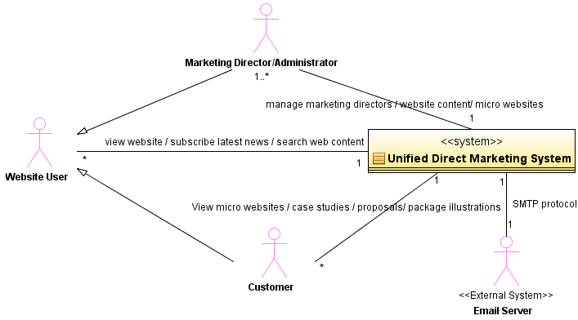
Figure 1: System Context Diagram

Table 1: Actors Summary
Actor | Description | Responsibilities
Website User | All users who visit UDM website | - Browse the website  - Subscribe to latest news  - Search website content
Customer | Users that have mailed a micro website link | - View their related micro websites, proposals, package illustrations, and case studies
Marketing Director | UDM staff that can modify the website, view internal artifacts or authorize users in the system | - View, add, and delete marketing director accounts  - View, create, edit, and delete a micro website  - Add and delete case studies  - Email a micro website link  - Edit website content  - View subscribers’ email
Email Server | An external system that enable the UDM system to send web micro website links to users | - Send emails to users

Artifacts & Information 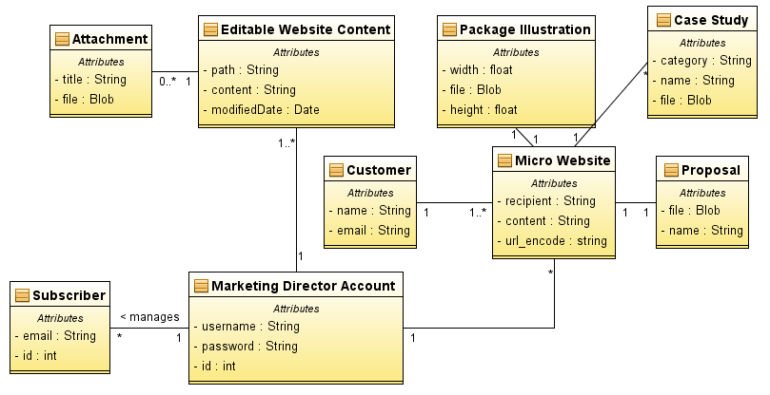
*Attributes in each block are auto-generated by the modeling tool.
Figure 2: Artifacts and Information Diagram

Table 2: Artifacts and Information Summary
Artifact | Purpose
Marketing Director Account | Marketing Director Account contains user name and password for authentication purpose.
Customer | A Customer record is UDM customers’ information in the system. It contains a customer’s name and email for sending a micro website link.
Proposal | A Proposal is the main document in a Micro Website containing UDM’s service information for a customer.
Micro Website | A Micro Website is the website generated for each UDM customer containing messages, the proposal, the package illustration, and case studies.
Attachment | An attachment contains file name and the file instance for each uploaded attachment in editable website content.
Editable Website Content | Editable Website Content represents content on the UDM website that is editable.
Package Illustration | A package illustration is the document attached in a micro website showing the dimensional illustration of a physical package.
Case Study | A case study is the document attached in a micro website showing relevant sample UDM products.
Subscriber | A Subscriber record is a user’s email information for UDM staff to send latest news.

Behavior
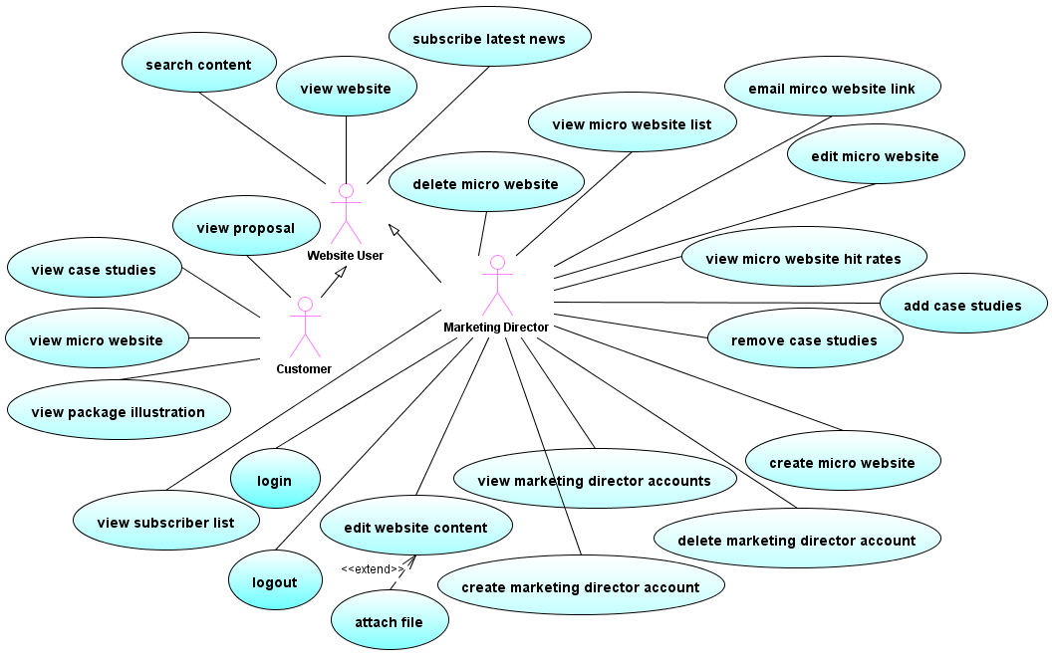
Figure 3: Process Diagram

Authentication

Login
Table 3: Process Description (Login)
Identifier | UC-1: Login
Purpose | Authorizing a user to log into the system as a marketing director
Requirements | WC_1536: As a marketing director I can obtain a login credential to the web system so that I may login to modify the web site and micro websites using the CMS
Development Risks | Secure connection protocol may be required.
Pre-conditions | The user is on login page.
Post-conditions | The user is logged in as a marketing director.  Unauthorized users are denied.

Table 4: Typical Course of Action (Login)
Seq# | Actor’s Action | System’s Response
1 | Enter username and password
2 | Clicks the Login button
3 |  | Verify username and password
4 |  | The username/password pair is in the database.
5 |  | Authorize the user
6 |  | Redirect the user to Marketing Director’s homepage.
Table 5: Exceptional Course of Action (Login: Access deny)
Seq# | Actor’s Action | System’s Response
1 | Enter username and password
2 | Click the Login button
3 |  | Verify username and password
4 |  | The username/password pair is not in the database; show “invalid username/password pair” message.

Logout
Table 6: Process Description (Logout)
Identifier | UC-2: Logout
Purpose | Logging out a marketing director who has logged in.
Requirements | WC_1536: As marketing director I can obtain a login credential to the web system so that I may login to modify the web site and micro websites using the CMS
Development Risks | None
Pre-conditions | The user has logged into the system as a marketing director.
Post-conditions | The marketing director logged out, and the session is terminated.

Table 7: Typical Course of Action (Logout)
Seq# | Actor’s Action | System’s Response
1 | Click the Logout button
2 |  | Log the user out and deactivate the user’s session
3 |  | Redirect the user to the log in page

Table 8: Alternate Course of Action (Logout: Timeout)
Seq# | Actor’s Action | System’s Response
1 | Idle for 30 or more minutes
2 |  | Log the user out and deactivate the user’s session

Table 9: Exceptional Course of Action (Logout: Timeout)
Seq# | Actor’s Action | System’s Response
1 | Click the Logout button
2 |  | The user’s session is deactivated; redirect the user to the log in page.

Account Management

Create Marketing Director Account
Table 10: Process Description (Create Marketing Director Account)
Identifier | UC-3: Create marketing director account
Purpose | Adding a new marketing director account into the system
Requirements | WC_1536: As a marketing director I can obtain a login credential to the web system so that I may login to modify the web site and micro websites using the CMS
Development Risks | None
Pre-conditions | The user has logged in as a marketing director.  The user is on Account Management page.
Post-conditions | A new user can login as a marketing director.

Table 11: Typical Course of Action (Create Marketing Director Account)
Seq# | Actor’s Action | System’s Response
1 | Click “Create Account” button
2 |  | Redirect to an empty Marketing Director Account form
3 | Fill in the Marketing Director Account form with username & password and click Create
4 |  | Check input format and record redundancy.
5 |  | Add new Marketing Director Account record to the database
6 |  | Redirect to View Market Director Accounts page

Table 12: Exceptional Course of Action (Create Marketing Director Account: User exists)
Seq# | Actor’s Action | System’s Response
1 | Click “Create Account” button
2 |  | Redirect to an empty Marketing Director Account form
3 | Fill in the Marketing Director Account form with username & password and click Create
4 |  | Check input format and record redundancy.
5 |  | The account exists in the database; return to the Marketing Director Account and show “username exists” message.

Delete Marketing Director Account
Table 13: Process Description (Delete Marketing Director Account)
Identifier | UC-4: Delete marketing director account
Purpose | Deleting a marketing director account from the system
Requirements | WC_1536: As a marketing director I can obtain a login credential to the web system so that I may login to modify the web site and micro websites using the CMS
Development Risks | None
Pre-conditions | The user has logged in as a marketing director.  The user is on Account Management page.
Post-conditions | A marketing director account is removed from the system.

Table 14: Typical Course of Action (Delete Marketing Director Account)
Seq# | Actor’s Action | System’s Response
1 | Click “Delete Account” button
2 |  | Redirect to a Delete Marketing Director Account form
3 | Fill in the username and click “Delete” button
4 |  | Popup a Confirm box with “Confirm” and “Cancel” buttons.
5 | Click “Confirm” button
6 |  | Check the user is not deleting itself or an invalid username.
7 |  | The user is not deleting itself or an invalid username; delete the Marketing Director Account record from the database.
8 |  | Redirect to View Market Director Accounts page
Table 15: Alternate Course of Action (Delete Marketing Director: Cancel)
Seq# | Actor’s Action | System’s Response
1 | Click “Delete Account” button
2 |  | Redirect to a Delete Marketing Director Account form
3 | Fill in the username and click “Delete” button
4 |  | Popup a Confirm box with “Confirm” and “Cancel” buttons.
5 | Click “Cancel” button
6 |  | Redirect to View Market Director Accounts page

Table 16: Exceptional Course of Action (Delete Marketing Director: Failure)
Seq# | Actor’s Action | System’s Response
1 | Click “Delete Account” button
2 |  | Redirect to the Delete Marketing Director Account form
3 | Fill in the username and click “Delete” button
4 |  | Popup a Confirm box with “Confirm” and “Cancel” buttons.
5 | Click “Confirm” button
6 |  | Check the user is deleting itself or an invalid username.
7 |  | The user is deleting itself or an invalid username; return to Delete Marketing Director Account form and display failure message.

View Marketing Director Accounts
Table 17: Process Description (View marketing director accounts)
Identifier | UC-5: View marketing director accounts
Purpose | Showing all Marketing Director Account records
Requirements | WC_1536: As a marketing director I can obtain a login credential to the web system so that I may login to modify the web site and micro websites using the CMS
Development Risks | None
Pre-conditions | The user has logged in as a marketing director.  The user is on Account Management page.
Post-conditions | A list of all Marketing Director Account records is shown.

Table 18: Typical Course of Action (View marketing director accounts)
Seq# | Actor’s Action | System’s Response
1 | Enter “Account Management” Page
2 |  | Retrieve a list of all Marketing Director account records from the database in alphabetical order.
3 |  | Display all Marketing Director accounts

Micro Website Management

Create Micro Website
Table 19: Process Description (Create Micro Website)
Identifier | UC-6: Create micro website
Purpose | Creating a micro website for a customer and return the URL link
Requirements | WC_1373: As a marketing director, I can generate a micro website for the project proposal from the website so that I do not have to manually generate the micro website.  WC_1372: As a marketing director, I can post related proposal content on the micro website so that my proposal micro website can stand out to the client.  WC_1371: As marketing director, during the micro website generation I can add or delete promotional information, to include pdf files, visible on the micro website so that my proposal micro website can stand out to the client.
Development Risks | The link must be irredundant, so an effective encoding algorithm is required.
Pre-conditions | The user has logged in as a marketing director.  The user is on Micro Website Management page.
Post-conditions | A micro website containing a proposal file, a package illustration file, and optional relevant case studies is generated and its link is shown.

Table 20: Typical Course of Action (Create Micro Website)
Seq# | Actor’s Action | System’s Response
1 | Click “Create Micro Website” button
2 |  | Redirect to an empty “Micro Website” form
3 | Fill in recipient’s name and email, upload a proposal file, select a package illustration, and optionally chose relevant case studies.
4 | Click “Create” button
5 |  | Redirect to an emailing page and display the link of the micro website.

Table 21: Exceptional Course of Action (Create Micro Website)
Seq# | Actor’s Action | System’s Response
1 | Click “Create Micro Website” button
2 |  | Redirect to an empty “Micro Website” form
3 | Fill in recipient’s name and email, upload a proposal file, select a package illustration, and optionally chose relevant case studies.
4 | Click “Create” button
5 |  | The file is not in PDF format or required field is not filled. Show failure message.

Edit Micro Website
Table 22: Process Description (Edit Micro Website)
Identifier | UC-7: Edit Micro Website
Purpose | Editing a micro website by modifying recipient information, re-uploading the proposal, editing marketing information, or reselecting related proposal content.
Requirements | WC_1536: As a marketing director I can obtain a login credential to the web system so that I may login to modify the web site and micro websites using the CMS  WC_1535: As a marketing director, I can modify the content of a micro website after one has been generated, so that I may modify the proposal and marketing information pdfs after the micro sites are generated.  WC_1372: As a marketing director, I can post related proposal content on the micro website so that my proposal micro website can stand out to the client.
Development Risks | None
Pre-conditions | The user has logged in as a marketing director.  The edited micro website exists.  The user is on Micro Website Management page.
Post-conditions | The micro website is updated.

Table 23: Typical Course of Action (Edit Micro Website)
Seq# | Actor’s Action | System’s Response
1 | Click “Edit” button of a micro website record
2 |  | Redirect to a “Micro Website” form with filled fields according to the edited micro website
3 | Modify recipient information, re-upload the proposal, edit marketing information, or reselect related proposal content.
4 | Click “Submit” button
5 |  | Redirect to Micro Website Management page.

Table 24: Exceptional Course of Action (Edit Micro Website)
Seq# | Actor’s Action | System’s Response
1 | Click “Edit” button of a micro website record
2 |  | Redirect to a “Micro Website” form with filled fields according to the edited micro website
3 | Modify recipient information, re-upload the proposal, edit marketing information, or reselect related proposal content.
4 | Click “Submit” button
5 |  | The file is not in PDF format, or required field is not filled. Show failure message.

Delete Micro Website
Table 25: Process Description (Delete Micro Website)
Identifier | UC-8: Delete Micro Website
Purpose | Deleting a micro website and destroying its link
Requirements | WC_1536: As a marketing director I can obtain a login credential to the web system so that I may login to modify the web site and micro websites using the CMS  WC_1535: As a marketing director, I can modify the content of a micro website after one has been generated, so that I may modify the proposal and marketing information pdfs after the micro sites are generated.
Development Risks | None
Pre-conditions | The user has logged in as a marketing director.  The micro website exists.  The user is on Micro Website Management page.
Post-conditions | The micro website content, the proposal file and the link are deleted or not.
Table 26: Typical Course of Action (Delete Micro Website)
Seq# | Actor’s Action | System’s Response
1 | Click “Delete” button of a micro website record
2 |  | Popup a confirm box with “Confirm” and “Cancel” buttons
3 | Click “Confirm” button.
4 |  | Delete micro website and deactivate the link
5 |  | Redirect to Micro Website Management page.
Table 27: Alternate Course of Action (Delete Micro Website: Cancel)
Seq# | Actor’s Action | System’s Response
1 | Click “Delete” button of a micro website record
2 |  | Popup a confirm box with “Confirm” and “Cancel” buttons
3 | Click “Cancel” button.
4 |  | Redirect to Micro Website Management page.

View Case Studies
Table 28: Process Description (View Case Studies)
Identifier | UC-12: View case studies
Purpose | Viewing case studies on a micro website
Requirements | WC_1372: As a marketing director, I can post related proposal content on the micro website so that my proposal micro website can stand out to the client.  WC_1542: As a marketing director, I can select relevant case studies for each micro website which are only accessible through those micro websites they belong to.
Development Risks | Case studies are only accessible via micro websites. It may require subtle session management techniques.
Pre-conditions | The micro website exists.  Those case studies are uploaded.  The customer accessed case studies via the micro website.
Post-conditions | Case studies are shown.

Table 29: Typical Course of Action (View Case Studies)
Seq# | Actor’s Action | System’s Response
1 | Click “Relevant Case Studies” button on a micro website.
2 |  | Check the user’s permission, i.e. the user is directed from the micro website.
3 |  | The user has permission to view; retrieve case studies from the database
4 |  | Display “Case Studies” content
Table 30: Exceptional Course of Action (View Case Studies: Failure)
Seq# | Actor’s Action | System’s Response
1 | Access case studies by entering the case studies’ URL
2 |  | Check the user’s permission, i.e. the user is directed from the micro website.
3 |  | The user is not directed from micro websites; response Error 404 “Forbidden”.

Add Case Studies
Table 31: Process Description (Add Case Studies)
Identifier | UC-24: Add case studies
Purpose | Add a case study record
Requirements | WC_1372: As a marketing director, I can post related proposal content on the micro website so that my proposal micro website can stand out to the client.
Development Risks | None
Pre-conditions | The user has logged in as a marketing director.  The user is on Micro Website Management page.
Post-conditions | A record of a case study is added to the database.  A category of case studies is added to the database.

Table 32: Typical Course of Action (Add Case Studies)
Seq# | Actor’s Action | System’s Response
1 | Click “Add Case Studies” button on a micro website management page.
2 |  | Show empty “Case Study” form
3 | Fill in name, select the category, and upload the file. Click submit button.
4 |  | Upload the file and create a new record of the case study in the database.
5 |  | Show success message
Table 33: Alternate Course of Action (Add Case Studies: Create new category)
Seq# | Actor’s Action | System’s Response
1 | Click “Add Case Studies” button on a micro website management page.
2 |  | Show empty “Case Study” form
3 | Fill in name, input the category name, and upload the file. Click submit button.
4 |  | Upload the file and create new records of case studies and categories in the database.
5 |  | Show success message

Table 34: Exceptional Course of Action (Add Case Studies: Failure)
Seq# | Actor’s Action | System’s Response
1-4 | As in Typical/Alternate Course of Action.
5 |  | Fail to upload due to format or size error.
6 |  | Show failure message

Remove Case Studies
Table 35: Process Description (Remove Case Studies)
Identifier | UC-25: Remove case studies
Purpose | Removing a case study
Requirements | WC_1372: As a marketing director, I can post related proposal content on the micro website so that my proposal micro website can stand out to the client.
Development Risks | None
Pre-conditions | The user has logged in as a marketing director.  A record of case studies exists in the database.  The user is on Micro Website Management page.
Post-conditions | A record of case study is removed from the database

Table 36: Typical Course of Action (Remove Case Studies)
Seq# | Actor’s Action | System’s Response
1 | Click “Remove Case Studies” button on a micro website. Management page
2 |  | Show a list of case studies
3 | Select a case study. Click “Remove” button.
4 |  | Delete the record from the database
5 |  | Show success message

Table 37: Exceptional Course of Action (Remove Case Studies: Failure)
Seq# | Actor’s Action | System’s Response
1 | Click “Remove Case Studies” button on a micro website. Management page
2 |  | Show a list of case studies
3 | Select a case study. Click “Remove” button.
4 |  | The record doesn’t exist in the database; show error message.

Email Micro Website Link
Table 38: Process Description (Email Micro Website Link)
Identifier | UC-13: Email micro website link
Purpose | Emailing the link of a micro website
Requirements | WC_1366: As a marketing director, I can have the web system send an email link of the micro website to my customers so that they may see the proposal document and related marketing content.
Development Risks | Communication between the system and the email server is based on SMTP protocol. Need to find a way to retrieve error message in the protocol.
Pre-conditions | The email server is connected.  The micro website exists.  The user has logged in as a marketing director.  The user is on Micro Website Management page.
Post-conditions | The link of a micro website is sent to a customer via email

Table 39: Typical Course of Action (Email Micro Website Link)
Seq# | Actor’s Action | System’s Response
1 | Click “Send to Recipient” button on the micro site record.
2 |  | Popup a Confirm box with “Confirm” and “Cancel” buttons.
3 | Click “Confirm” button
4 |  | Send an email containing the micro website link to the user.
5 |  | The mail is sent successfully; return to “Micro Website Management” page and show success message.
Table 40: Alternate Course of Action (Email Micro Website Link: Cancel)
Seq# | Actor’s Action | System’s Response
1 | Click “Send to Recipient” button on the micro site record.
2 |  | Popup a Confirm box with “Confirm” and “Cancel” buttons.
3 | Click “Cancel” button
4 |  | Return to “Micro Website Management” page.

Table 41: Exceptional Course of Action (Email Micro Website Link: Failure)
Seq# | Actor’s Action | System’s Response
1 | Click “Send to Recipient” button on the micro site record.
2 |  | Popup a Confirm box with “Confirm” and “Cancel” buttons.
3 | Click “Confirm” button
4 |  | Send an email containing the micro website link to the user.
5 |  | The email server returns a failure message; return to “Micro Website Management” page and show failure message.

Website Management

Edit Website Content
Table 42: Process Description (Edit Website Content)
Identifier | UC-14: Edit website content
Purpose | Changing the text or appearance of UDM website
Requirements | WC_1536: As a marketing director I can obtain a login credential to the web system so that I may login to modify the web site and micro websites using the CMS.  WC_1375: As a web administrator, I can manage content of the website from the system so that I do not need to be a software developer to make modifications during the maintenance phase.
Development Risks
Pre-conditions | The user has logged in as a marketing director.  The user is on Website Management page.
Post-conditions | The content of the website is updated.

Table 43: Typical Course of Action (Edit Website Content)
Seq# | Actor’s Action | System’s Response
1 | Click “Edit Page” button
2 |  | Redirect to a “Editable Website Content” form
3 | Fill in new content
4 | Click “Update” button
5 |  | Update successfully; redirect to the updated page.

Table 44: Exceptional Course of Action (Edit Website Content: Failure)
Seq# | Actor’s Action | System’s Response
1 | Click “Edit Page” button
2 |  | Redirect to a “Editable Website Content” form
3 | Fill in new content
4 | Click “Update” button
5 |  | HTML content corrupts e.g. tags are not matched; show error message.

Attach File
Table 45: Process Description (Attach File)
Identifier | UC-15: Attach file
Purpose | Attaching files to the website content
Requirements | WC_1370: As a marketing director, I can access marketing information on the resources page website so that I can see information on clients for UDM. Marketing information will include pdf files.
Development Risks | None
Pre-conditions | The user has logged in as a marketing director.  The user is on Website Management page.
Post-conditions | A file is uploaded to a webpage.

Table 46: Typical Course of Action (Attach File)
Seq# | Actor’s Action | System’s Response
1 | Click “Upload” button
2 |  | Display “Select files” box
3 | Select a file and click upload
4 |  | Check file validity
5 |  | Transmit the file
6 |  | Show the uploaded file’s link
Table 47: Exceptional Course of Action (Attach File: Failure)
Seq# | Actor’s Action | System’s Response
1 | Click “Upload” button
2 |  | Display “Select files” box
3 | Select a file and click upload
4 |  | Check file validity
5 |  | The file is not valid ; show “Upload fail” Message

Subscription

Subscribe latest news
Table 48: Process Description (Subscribe latest news)
Identifier | UC-22: Subscribe Latest News
Purpose | Joining the email list of UDM so as to receive latest news.
Requirements | WC-1539: As a visitor to the website I can subscribe to the latest events and discount information from UDM so that I may receive a notification when new events and discounts are available on the website.
Development Risks | None
Pre-conditions | Provided email address is in correct format.
Post-conditions | The subscriber’s email is in the database.

Table 49: Typical Course of Action (Subscribe latest news)
Seq# | Actor’s Action | System’s Response
1 | Input email address in subscribe bar on the website.
2 | Click “Subscribe” button
3 |  | Check email redundancy
4 |  | Not record exists; add a Subscriber record to the database
5 |  | Show “Success” message
Table 50: Alternate Course of Action (Subscribe latest news: Subscribed)
Seq# | Actor’s Action | System’s Response
1 | Input email address in subscribe bar on the website.
2 | Click “Subscribe” button
3 |  | Check email redundancy
4 |  | The email exists; show “The email has already subscribed.” message

Modes of Operation
Unified Direct Marketing system will operate in only one mode, so there is no additional information concerning modes of operations provided.

System Analysis Rationale
Operational stakeholders of the system to be built are divided into the following three categories:
- Customers: users who have contacted UDM and for whom UDM has created a micro website. Notice that customers don’t need to login to access their micro websites and materials within micro websites. Instead, the micro website link is user-specific by itself. Because of this nature, the link of each micro website should be properly hashed so that customers can’t easily guess other customers’ micro website link.

- Marketing directors: users who can add/update/delete micro website and content of the UDM website. In other words, marketing directors are administrators in this system.

- Website users: users who visit the website and subscribe latest news from UDM.

Notice that only marketing directors need to login to operate, other users are simply website visitors. The significant difference between customers and website users is that customers have a micro website associated with them whereas pure website users don’t. Also notice that the subscription function is simply recording the email of each subscriber. As confirmed with the client, the client would like to use emailing software to email latest news manually, so there is no counterpart such as emailing subscribers function in this system.

NDI/NCS Interoperability Analysis

Introduction
Authentication, Account Management, and Website Management parts can be directly fulfilled by an existing CMS. Other functions can also be added on to the CMS with customizing code. Customizing code is built onto the existing development framework and the CMS as modules that connects with the CMS via its MVC configuration. Though the Architected-agile process pattern is used in this project, since the overall architecture is defined by the FuelCMS, no overall design is required in this document, so NDI/NCS information instead of technology-specific design is shown.

COTS / GOTS / ROTS / Open Source / NCS
Table 51: NDI Products Listing
NDI/NCS Products | Purposes
CodeIgniter 2.1.3 | To ease development
FuelCMS 0.9.3 | To fulfill authentication, account management, and website management functions.
MySQL 5.5 | To store data
jQuery 1.8.3 | To ease front-end development
Apache HTTP Server 2.2 | To provide web server functionality
PHP 5.4

Connectors
- PHP/MySQL connector (mysqlnd 5) is used to connect the MySQL database.
- The system connects with the email server following the SMTP protocol.
- Customized modules connect with Fuel CMS Module Framework by extending Base_module_model class, creating a table in the database, and changing the module configuration file.

Legacy System
No legacy system is integrated with the proposed system.

System Structure
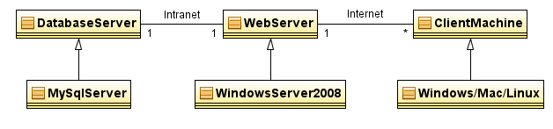
Figure 4: Hardware Component Class Diagram

Database Server
Web Server
Client Machine
Email Server
MySQL 5.5
Apache Web Server 2.2
PHP 5.4
Fuel CMS 0.9.3
CodeIgniter 2.1.3
IE 8-9
Chrome 20-25
SMTP
Internet
Intranet
Figure 5: Deployment Diagram

Evaluation Summary
Table 52: NDI Evaluation
NDI | Usages | Comments
CodeIgniter | Development framework for back-end development | The framework is free and uses MVC architecture and provides abundant helper libraries to facilitate development.
FuelCMS | To implement authentication, account management, and website management functions. Other functions are also built on the CMS. | The CMS is free and provides user authentication, user management, website management, and blogging functions to fulfill the requirements. It’s not popular but has complete documents. It is built upon the CodeIgniter framework and follows CodeIgniter’s file and class structures.
jQuery | Javascript Library for font-end development | A free and useful javascript library that can accelerate front-end development.
MySQL | Database | The database used by the web hosting service. It’s free and has abundant technical supports.
Apache Web Server | Web server | The web server used by the web hosting service.

Technology-Specific System Design

Design Overview

Module Structure

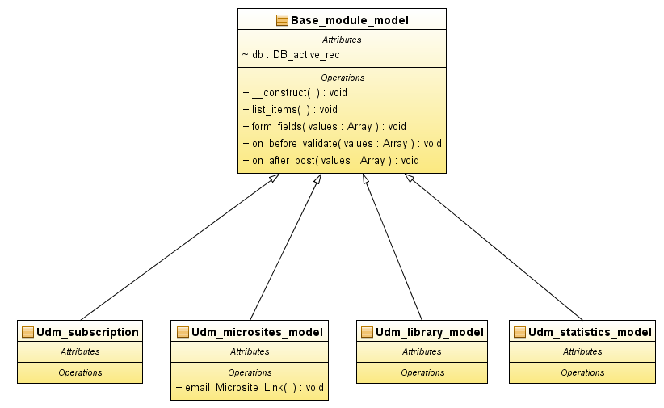
Figure 6: Module Class Diagram

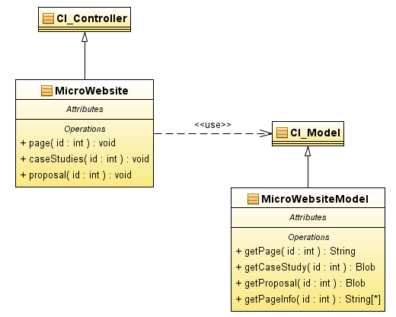
Figure 7: Micro Website Controller Class Diagram
Table 53: Design Class Description
Class | Type | Description
Base_module_model | Model | The base class of all customized models in FuelCMS
Udm_subscription | Model | The module for managing the subscription list
Udm_microsites_model | Model | The module for managing micro websites and mailing micro website links
Udm_library_model | Model | The module for managing uploaded files
Udm_statistics_model | Model | The module for viewing website statistics, i.e. hit counts.
CI_Controller | Controller | The general controller in CodeIgniter 2
CI_Model | Model | The general model in CodeIgniter 2
MicroWebsite | Controller | The controller that processes customers’ requests to micro websites
MicroWebsiteModel | Model | The model that accesses micro website data from the database

Process Realization
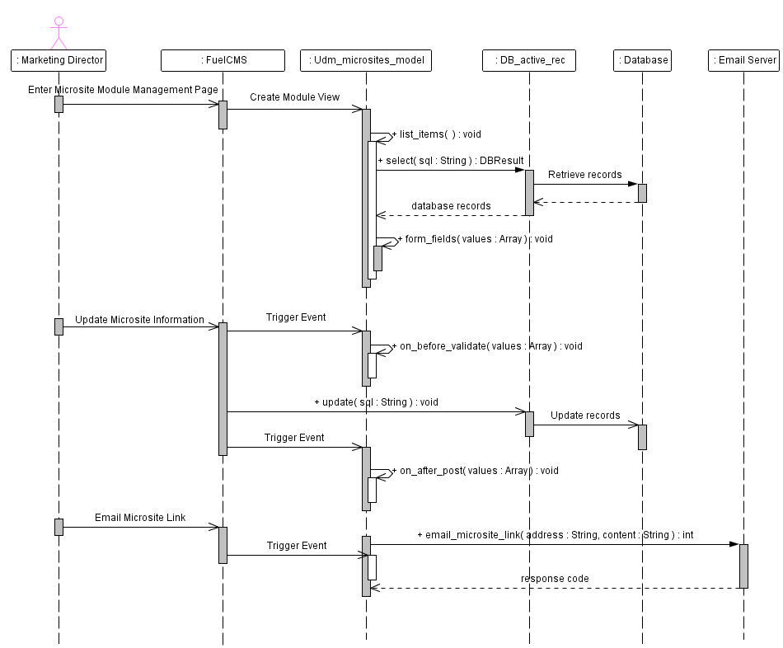
Figure 8: Micro Website Management Sequence Diagram
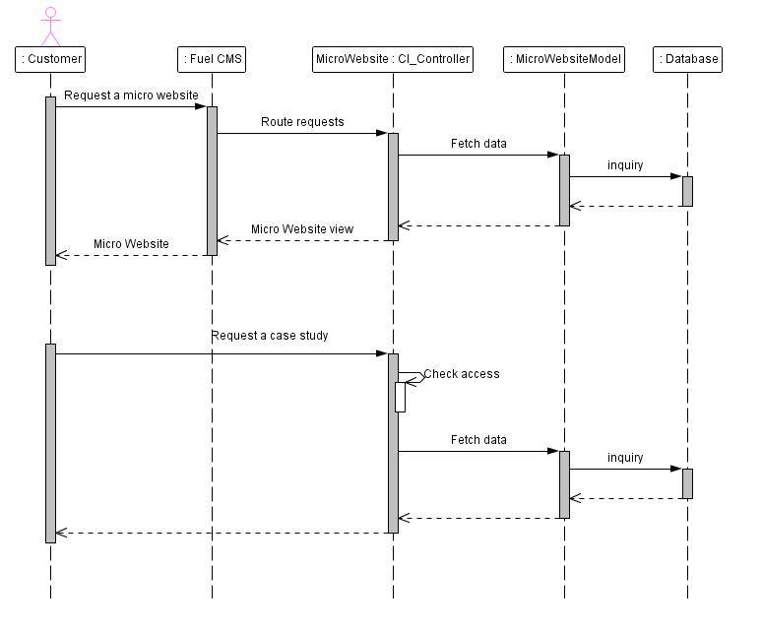
Figure 9: Micro Website Request Sequence Diagram

